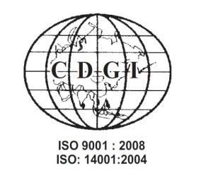
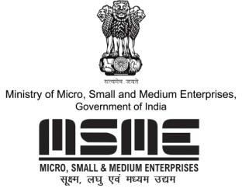
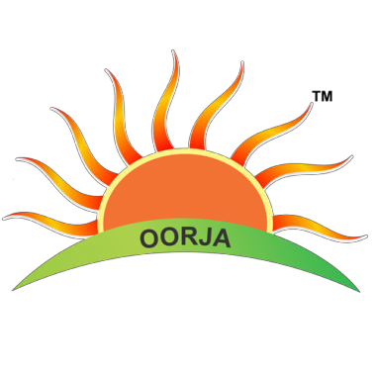

MSME TECHNOLOGY DEVELOPMENT CENTRE (CDGI)

MINISTRY OF MICRO, SMALL & MEDIUM ENTERPRISES, GOVT. OF INDIA

A1/1, Industrial Area, Jalesar Road, Firozabad 283203, Uttar Pradesh
•www.cdgiindia.net | Email: msme.cdgi@gmail.com
HOW TO SUCCESSFULLY VENTURE INTO BUSINESS OF
DIGITAL MARKETING & DIRECT SELLING
29th Feb. & 1st March, 2020
Fees: Rs. 5,500/- + 18% GST

VENUE
RTW SOLUTIONS PVT. LTD., A58/59, NANDJYOT INDUSTRIAL ESTATE, NEAR SAKINAKA TELEPHONE EXCHANGE, ANDHERI KURLA ROAD, ANDHERI(E) - 400072

TOPICS
DAY -1 DAY-2
• HOW TO SELECT THE BEST KEYWORDS FOR YOUR BUSINESS
• SOCIAL MEDIA MARKETING
• BUSINESS NETWORKING ON SOCIAL MEDIA
• SEARCH ENGINE OPTIMIZATION
• SOCIAL MEDIA OPTIMIZATION
• GETTING FOUNDS IN SEARCH RESULTS
• DIRECT SELLING TOOLS
• HOW TO SELL ONLINE ON AMAZON/FLIPKART ETC.
• HOW TO SET UP YOUR OWN DIRECT SELLING BUSINESS
• HOW TO MASTER THE ART AND SCIENCE OF DIRECT SELLING
• AVOID COMMON PITFALLS AND MAXIMISE YOUR EFECTIVENESS AND INCOME
• GOVERNMENT POLICIES REGARDING DIGITAL INDIA
• ONLINE BUSINESS STRATEGY
• HOW TO TAKE FREELANCING PROJECTS

• INTRODUCTION TO DIGITAL MARKETING, WHY ONLINE?
• HOW TO HOST A WEBSITE?
• WEBSITE PLANNING & CREATION OF A WEBSITE WITH ZERO TECHNICAL KNOWLEDGE
• WEBSITE OPTIMIZATION MARKETING
• CONTENT CREATION AND POSTING TRICKS ON SOCIAL MEDIA
• CONTENT DISTRIBUTION FOR ENGAGEMENT SOCIAL MEDIA
• CONTENT MARKETING
• E-MAIL SIGNATURE
• GOOGLE MY BUSINESS
• GOOGLE ANALYTICS
• MOBILE MARKETING
• PLAN DESIGNING YOUR ONLINE BUSINESS
• EARN PER CLICK /VISIT
• FINDING KEYWORDS FROM GOOGLE
• KEYWORD RESEARCH

FOR MORE DETAILS PLEASE CONTACT:
Mobile: +91- 8800924880, 8168984069
E-mail: msme.cdgi@gmail.com
Website: www.cdgiindia.net, www.oorjatrainings.com

