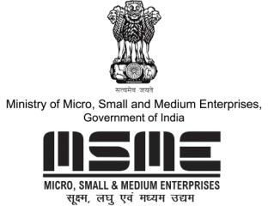

MSME TECHNOLOGY DEVELOPMENT CENTRE (CDGI)

MINISTRY OF MICRO, SMALL & MEDIUM ENTERPRISES, GOVT. OF INDIA

A1/1 , Industrial Area , Jalesar Road, Firozabad 283203, Uttar Pradesh
•www.cdgiindia.net | Email: msme.cdgi@gmail.com
BUSINESS OPPORTUNITIES & ENTERPRENEURSHIP ON SOLAR ENERGY
28th April 2019
Fees: Rs. 4,000/-

BUSINESS OPPORTUNITY ON PROTECTIVE CULTIVATION IN
ORGANIC FARMING
27th April 2019
Fees: Rs. 4,000/-

VENUE
HOTEL CITRUS, PLOT 34-35, FF SCHEME NO. 54, OPPOSITE MEGHDOOT GARDEN, VIJAY NAGAR, INDORE, M.P, 452010

- COURSE CURRICULUM FOR SOLAR ENERGY

COURSE CURRICULUM FOR ORGANIC FARMING
Topics
- Brief about Solar Energy.
- Electric power scenario in India
- Reasons to invest in solar in India
- Types of solar systems
- Solar PV system
- What is solar panels
- Types of solar panels available in market
- Types of solar cells (Technology)
- Types of solar PV systems
- What solar OFF – GRID / Roof Top system
- Solutions available of OFF – Grid System (Solar home pack system, street light etc.)
- SIZING OF SOLAR OFF GRID System
- Components OFF – GRID System
- Business Opportunities of solar ON Grid/OFF Grid (Roof Top) system in India market
- Exploring Customer Needs; Planning
- Relationship development with dealers and suppliers, customers
- Business development models for rural market / industrial / domestic
- Case study of solar PV System
- Open discussions /feedback session

- What is organic cultivation and its importance
- Which vegetables to grow
- Seeding production with soil less media
- Soil manure & nutrients
- Waste decomposition
- Organic vegetable cultivation and process
- Mushroom cultivation
- How to design poly house
- Business opportunities
- Policy
- Open discussions / feedback session
- PRACTICAL SESSION

FOR MORE DETAILS PLEASE CONTACT:
Mobile: +91- 8800924880, 8168984069
E-mail: msme.cdgi@gmail.com
Website: www.cdgiindia.net, www.oorjatrainings.com

